**How to configure a processor to run only once**

You can use the CRON driven option in the Scheduling strategy to have the flow run once. Or use the rest api to run the processor once.

Here is an example using the cron option, the below processor will run once on May 8th, 2017 at 10AM

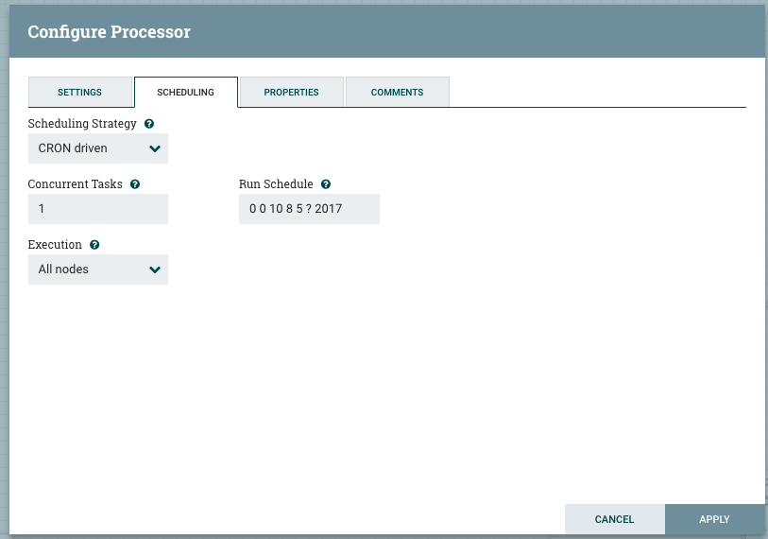

You can also use NiFi's rest-api to start and stop processors using a script.

<https://nifi.apache.org/docs/nifi-docs/rest-api/>